The Skeletal System
- Label all of the major bones; Cranium, mandible, vertebral column (including cervical vertebrae, thoracic vertebrae, lumbar vertebrae, clavicle, scapula, humerus, radius, ulna, carpels, metacarpels, phalanges, sternum, ribs pelvis, femur, patella, tibia, fibula, tarsels, metatarsels, phalanges

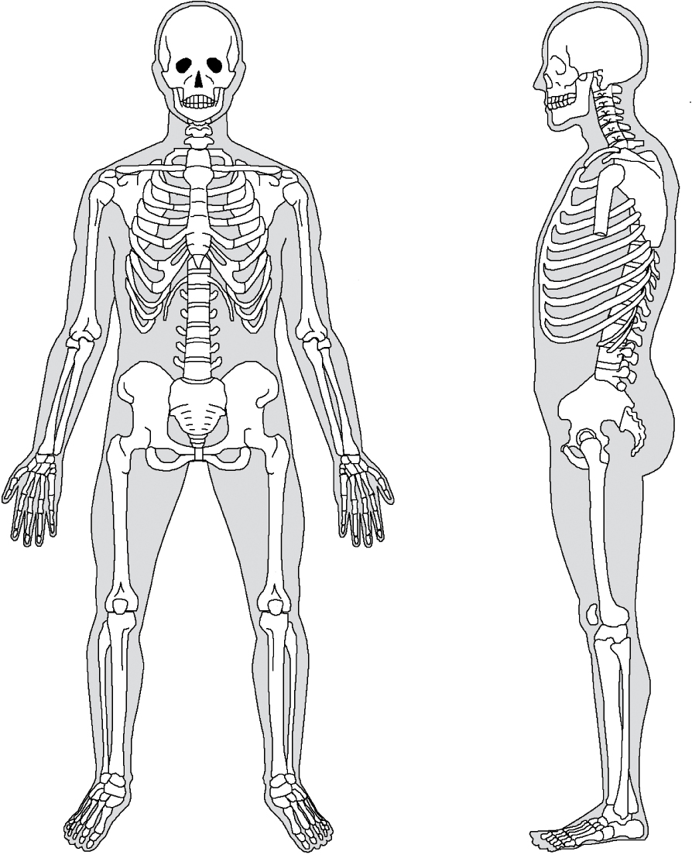

- Describe the function of the skeletal system;

