Year 8 Work, week beginning 13/7/2020

Geography: Finish your fact file on a river, make sure you’ve included lots of pictures and good information for me to read!

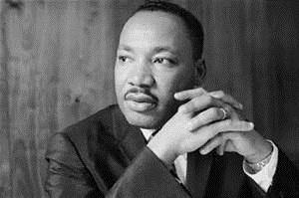
History: Watch and research the famous speech by Martin Luther King and answer the questions below on it: https://www.youtube.com/watch?v=KyI1LMmV3V0
When did he make this speech?
Why did he make this speech?
What was its aim?
Did it have an impact?

World Citizens: This week you are going to draw and design the idol you choose last week. Draw it out and label any important bits you want to tell me about. Make sure you tell me what you have picked and why!

Have a lovely summer holiday! I look forward to seeing you all in September!

