LO – To be able to round up sums of money.
Round the price of each item to the nearest £1 and the nearest 10p (Some have been done for you).
Item | Price | Nearest £1 | Nearest 10p
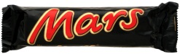  Mars Bar | £0.63 | £1 | £0.60
Walkers salt n vinegar crisps  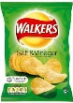 | £0.55
Teddy bear  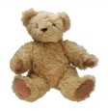 | £8.99
Tennis ball | £2.49 | £2 | £2.50
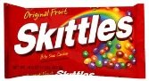  Skittles | £0.72
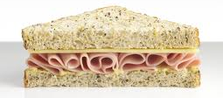  Ham sandwiches | £1.28 | £1
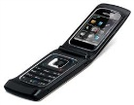  Mobile phone | £41.25
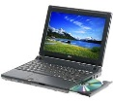  Laptop | £119.99 | £120 | £120.00
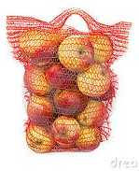  Bag of apples | £2.87
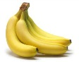  Bananas | £1.66
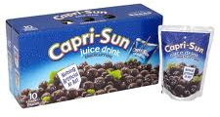  Blackcurrant juice | £4.13
Coco pops | £3.88 |  | £3.90
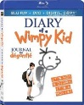  Diary of a Wimpy Kid DVD | £11.99
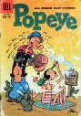  Comic | £2.60
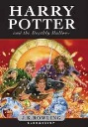  Harry Potter book | £8.50

