Name: NCFE Research Table

Project Resource Table
Topic researched | Unit & Task Number | Information or image found (sourced) | Source of Information/ Website address | Copyright permissions | Date information sourced
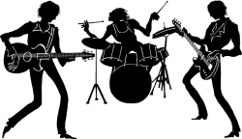 | Unit 01 task 1 | Image of a Pop band for my PP | Clip Art  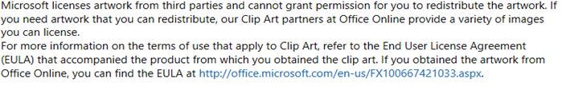 | I may use Clip Art in my school assignments | May 2020

