English Language: Week beginning 29th June 2020

These tasks concentrate on the skills needed for paper 1, question 3 of the GCSE Language paper.

Work can be completed electronically or handwritten. Then, it can be emailed to me via the email below. For the handwritten work, take a photo of the handwritten work and send it in this way.

Do not worry if do not understand all of the tasks, do what you can. If you have any questions about his work, or you would like to send your completed work, please email: amanda.dixon@grangepark.kent.sch.uk.

LO: To be able to identify how structure is used.

You are going to be looking at Paper 1, Question 3, which is the question about structure. Below are some PowerPoint slides outlining what you will expect see from the question and ideas on what you can do to help to write a response in an exam.

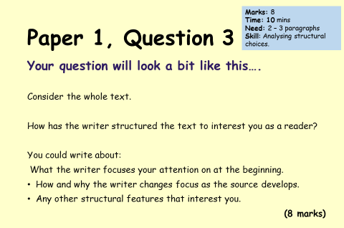
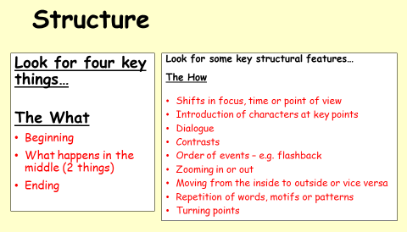
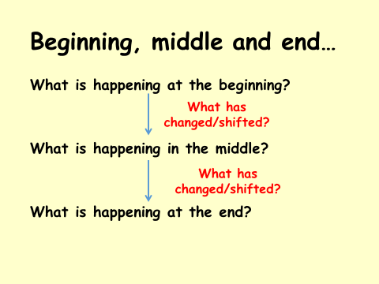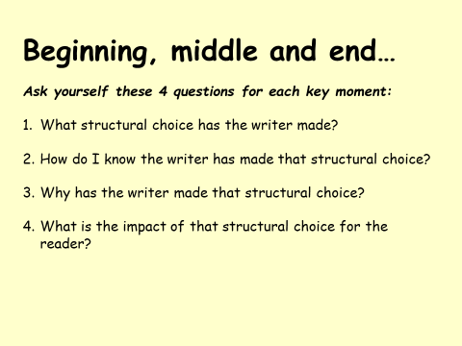

- Read the different sections of the extract below, then answer the questions for each section of the extract.
The extract is taken from Harry Potter – The Philosophers Stone and is split into 3 sections (beginning, middle and end).
Beginning:
Nearly ten years had passed since the Dursleys had woken up to find their nephew on the front step, but Privet Drive had hardly changed at all. The sun rose on the same tidy front gardens and lit up the brass number four on the Dursleys' front door; it crept into their living room, which was almost exactly the same as it had been on the night when Mr. Dursley had seen that fateful news report about the owls. Only the photographs on the mantelpiece really showed how much time had passed. Ten years ago, there had been lots of pictures of what looked like a large pink beach ball wearing different-colored bonnets -- but Dudley Dursley was no longer a baby, and now the photographs showed a large blond boy riding his first bicycle, on a carousel at the fair, playing a computer game with his father, being hugged and kissed by his mother. The room held no sign at all that another boy lived in the house, too. Yet Harry Potter was still there, asleep at the moment, but not for long. His Aunt Petunia was awake and it was her shrill voice that made the first noise of the day.

- This the beginning of the extract - what is happening?
- What has changed/shifted?
- What structural choice/s has the writer made (see ideas on PowerPoint slide)?
Middle:
Up! Get up! Now!“ Harry woke with a start. His aunt rapped on the door again. "Up!" she screeched. Harry heard her walking toward the kitchen and then the sound of the frying pan being put on the stove. He rolled onto his back and tried to remember the dream he had been having. It had been a good one. There had been a flying motorcycle in it. He had a funny feeling he'd had the same dream before. His aunt was back outside the door. "Are you up yet?" she demanded. "Nearly, " said Harry. "Well, get a move on, I want you to look after the bacon. And don't you dare let it burn, I want everything perfect on Duddy's birthday. "Harry groaned. "What did you say?" his aunt snapped through the door. "Nothing, nothing... "Dudley's birthday -- how could he have forgotten? Harry got slowly out of bed and started looking for socks. He found a pair under his bed and, after pulling a spider off one of them, put them on. Harry was used to spiders, because the cupboard under the stairs was full of them, and that was where he slept. When he was dressed he went down the hall into the kitchen.

- This the middle of the extract - what is happening?
- What has changed/shifted?
- What structural choice/s has the writer made (see ideas on PowerPoint slide)?

End:
The table was almost hidden beneath all Dudley's birthday presents. It looked as though Dudley had gotten the new computer he wanted, not to mention the second television and the racing bike. Exactly why Dudley wanted a racing bike was a mystery to Harry, as Dudley was very fat and hated exercise -- unless of course it involved punching somebody. Dudley's favourite punching bag was Harry, but he couldn't often catch him. Harry didn't look it, but he was very fast. Perhaps it had something to do with living in a dark cupboard, but Harry had always been small and skinny for his age. He looked even smaller and skinnier than he really was because all he had to wear were old clothes of Dudley's, and Dudley was about four times bigger than he was. Harry had a thin face, knobbly knees, black hair, and bright green eyes. He wore round glasses held together with a lot of Scotchtape because of all the times Dudley had punched him on the nose. The only thing Harry liked about his own appearance was a very thin scar on his forehead that was shaped like a bolt of lightning.

- This the end of the extract - what is happening?
- What has changed/shifted?
- What structural choice/s has the writer made (see ideas on PowerPoint slide)?

- Answer the exam style question.
Using the information you have gathered together, try to write a response to the exam question below.

Consider the whole text.

How has the writer structured the text to interest you as a reader?

You could write about:
- What the writer focuses your attention on at the beginning.
- How and why the writer changes focus as the source develops.
- Any other structural features that interest you.
[8 marks]

