Name Date

Formatting Exercise
Exercise 1 – Drag and Drop double click on the name of the room and drag it under the correct picture:
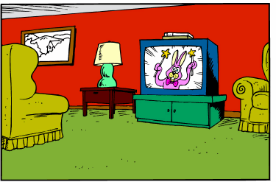 | 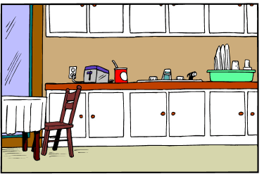 | kitchen  living room
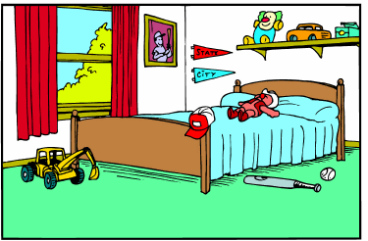 | 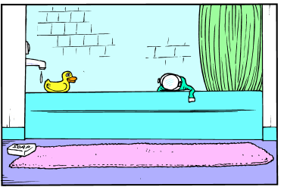 | bedroom  bathroom
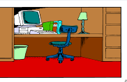 | 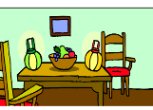 | dining room study
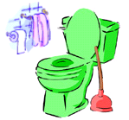 | 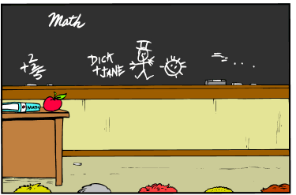 | toilet  classroom

Name Date

Format Exercise

Exercise 2 – Inserting Images
Use Clip Art to find a picture to match the words below and insert it in the column to the right of the word. Make the picture the same size as the first one (2cmx2cm) without distorting it.
Words | Pictures
Bath
Table
Chair
Elephant
Tree
Flower
Crane
Giraffe
Bicycle

Name Date
Format Activity
Exercise 2 – Alignment of Text
Task: Align, centre or bullet point the text below.
Align text left | Centre Text | Align text right
Cat  Dog  Mouse  Elephant | Castle  Tower  Drawbridge  Moat | Car  Train  Bus  Lorry
Centre Text | Align text right | Align text left
Oranges  Apples  Banana  Pineapple | Cabbage  Peas  Potatoes  Carrots | Arm  Leg  Head  Foot
Bullet Point the text | Number the text | Multilevel the text
Saucepan  Jug  Spatula  Whisk | Bunsen burner  Test-tube  Petra dish  Microscope | Pallet  Brush  Paint  Pastels

