Sports Equipment
Write which sport the equipment is used in.

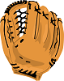 What sport uses this?
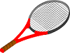What sport uses this?
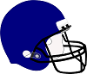 What sport uses this?
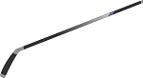What sport uses this?
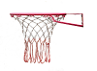What sport uses this?

