**Learning Objective:**

* To be able to recognise differences between reducing, reusing and recycling.

**Reduce, reuse, recycle…**

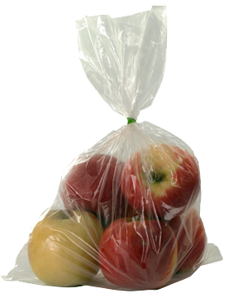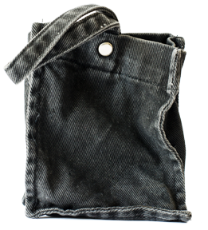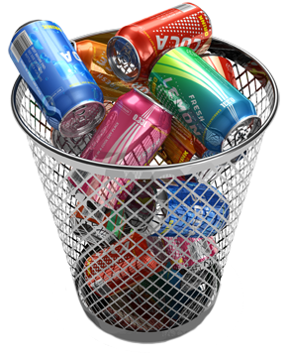

**How are they different?**

**Which do you do?**

**Reduce, reuse, recycle…**

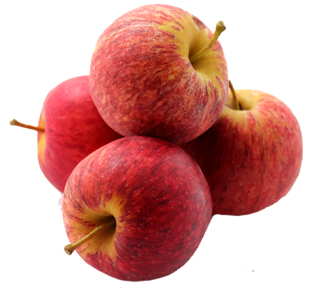

**Reduce, reuse, recycle…**

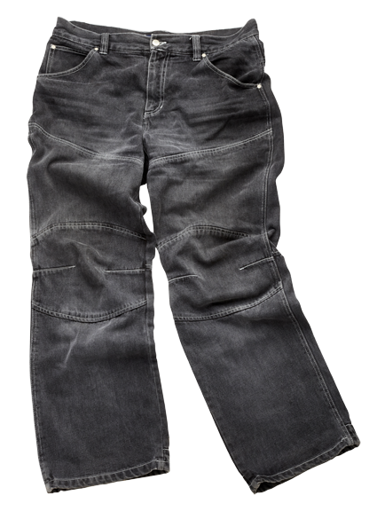

**Reduce, reuse,recycle…**

