1. Start researching ideas
2. Come up with possible designs
3. Collect materials
4. Make your chosen product

Everyone in your household can be involved so get creating and crafting now!

Recycling Project

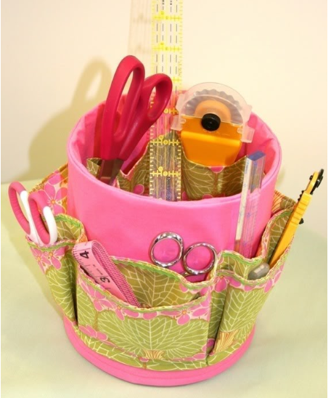

Your Task:

Design and make a product

Must be made out of recycled materials.

Turn one product into another useful product.

Project examples:

Milk Cartons into pencil holders

Odd puzzle pieces into picture frames

Broken pencils into pots

Plant pots from old pots

Useful storage containers from your old rubbish

