j0281116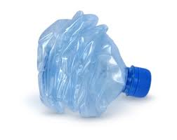Information Sheet for Plastic Wastage

Plastic is made from oil, a fossil fuel that will one day run out. Where possible we shouldn’t continue to use fossil fuels if the facilities exist to recycle materials that we already have.

**Plastic facts**

* 275,000 tonnes of plastic are used each year in the UK, that’s about 15 million bottles per day.
* Most families throw away about 40kg of plastic per year
* The use of plastic in Western Europe is growing about 4% each year.
* Plastic can take up to 500 years to decompose.
* 1 recycled plastic bottle would save enough energy to power a 60-watt light bulb for 6 hours
* An average 323 plastic bags are taken into our homes every year and it takes 500 years to decay when sent to landfill.

1. It takes about 25 recycled plastic drinks bottles to make one fleece jacket.

* Only 2.5% of plastic bottles are presently recycled in Europe

**What happens to the plastic bottles we recycle?**

The bottles are separated into their different types.The plastic is turned into pellets for companies to make new products from. The pellets are reheated and forced into a mould under pressure. Brand new products of all shapes and sizes are formed including plant pots, bins, water butts, garden furniture, drain pipes, and new plastic bottles!

**Future of Plastic Recycling?**

A growing recycling option which will hopefully become more and more widespread in the UK are Reverse Vending Machines, which collect plastics for recycling. These machines identify, sort, collect, process and recycle used beverage containers including PET (plastic) bottles and vending cups. These machines have been used in Europe for many years, often as part of a ‘refund for your empties’ scheme, encouraging people to put their bottles in to get money back. If placed in offices, shops and schools, these machines could make recycling a lot easier.