Listening preparation

What is a Coronation? ____________________________________________________
Look at these brass instruments – listen to them here: https://www.youtube.com/watch?v=P5162icRy6Y
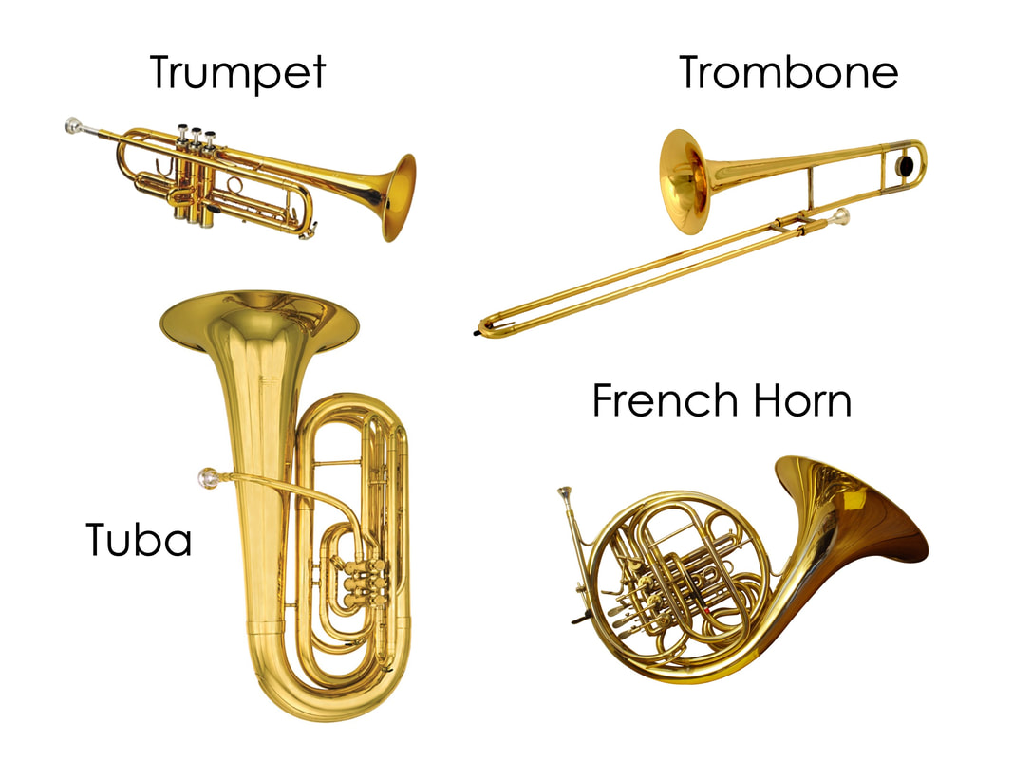
Look at these woodwind instruments – listen to them here: https://www.youtube.com/watch?v=Cwfj9Xx2LF4
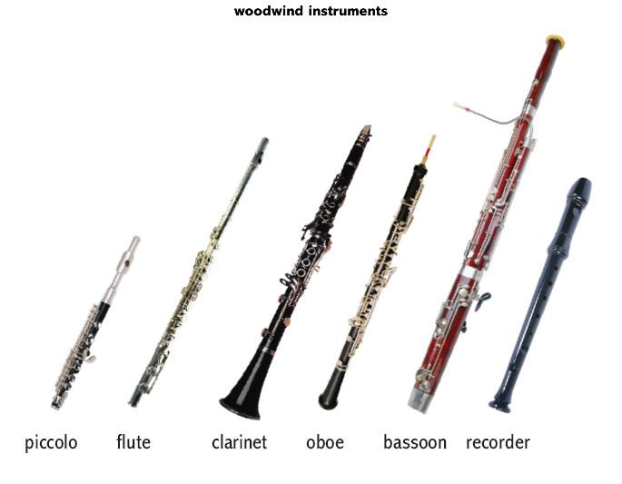
What does ‘dynamics’ mean? _____________________________________________
What does ‘tempo’ mean? _______________________________________________
What are percussion instruments? ________________________________________

Scan the QR code and listen to a famous piece of music called “Zadok the Priest” by the composer Handel and answer the questions below. If you cannot scan the code, follow this link: http://www.musicalcontexts.co.uk/index_files/MDP/SQUILT/SQUILTA3.mp3

1. What is the name of the only brass instrument that you can hear?

2. What is the name of the only percussion instrument that you can hear?

3. Name one woodwind instrument that you can hear.

4. How does Handel build up the excitement in the opening section of Zadok the Priest?

5. Describe the dynamics in the section up to when the voices enter (bonus marks for using the correct Italian term and/or musical symbols).

6. Zadok the Priest has been performed at every coronation in England since it was first written. What makes it so appropriate to such a special occasion?

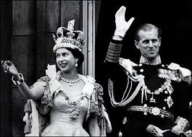
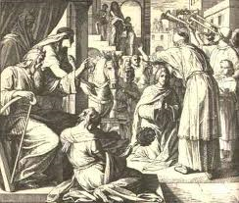

Zadok the Priest crowns Solomon Queen Elizabeth II’s Coronation

Scan the QR code to listen to five different pieces of vocal music. http://www.musicalcontexts.co.uk/index_files/FREE/SQUILT/SQUILTA11.mp3

As you listen, select ONE feature from the TYPES OF VOICES column (a-e) TWO features from the VOCAL FEATURES column (a-f) that match the music best and ONE OCCASION where you might expect to hear that type of singing (choose from the list of 8 occasions below).
You do not have to use each description and you may use any description more than once if you choose.
 | TYPES OF VOICES  CHOOSE ONE PER PIECE  a) women’s voices only  b) men’s voices only  c) women and men’s voices  d) children’s voices  e) crowd singing | VOCAL FEATURES  CHOOSE TWO PER PIECE  a) only the lead singer sings the words  b) call and response  c) singing in unison  d) singing in harmony  e) a cappella  f) voices echo and imitate each other | OCCASION WHERE YOU MIGHT EXPECT TO HEAR THIS TYPE OF SINGING  CHOOSE ONE PER PIECE  Choose from the list below.
Extract 1
Extract 2
Extract 3
Extract 4
Extract 5
KEY WORDS HELP
UNISON – all voices singing the same part/pitch at the same time – no “harmony”
HARMONY – voices singing different pitches combining together to form a blend of sound
A CAPPELLA – unaccompanied – without instruments, just voices
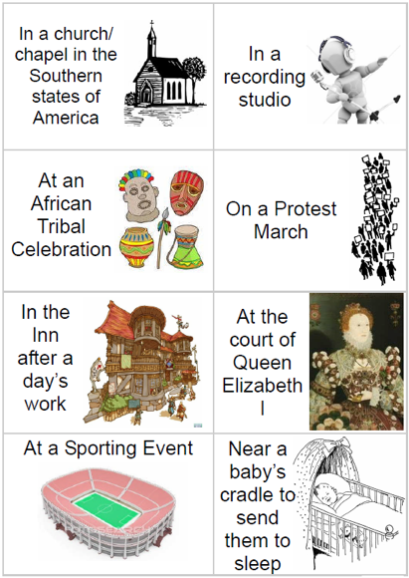

Scan the QR code and listen to a famous piece of music called “The Ritual Fire Dance” by the composer Manuel de Falla and answer the questions below. http://www.musicalcontexts.co.uk/index_files/MDP/SQUILT/SQUILTA4.mp3

- Which TWO words best describe the sounds heard at the very start of the extract, during the introduction?

Smooth Calm Buzzing Golden Chirpy Melodious

- After the introduction, the melody(tune) is played by an oboe. What instruments play the melody after the oboe?

- How would you describe the dynamics in “The Ritual Fire Dance”?

Very Soft Moderately Loud Very Loud Constantly Changing Soft

- How would you describe the tempo of “The Ritual Fire Dance”? (give an Italian musical word if you can!)

- Describe what happens towards the very end of the music.

- What percussion instrument can you hear right at the very end of the extract which finishes the piece?

- Draw and colour a picture below, showing what comes into your own mind when you listen to “The Ritual Fire Dance”.

