LO – To be able to calculate missing angles on a straight line and at a point.

Fill in the gaps.
Use the mymaths lesson to help if you can not remember.

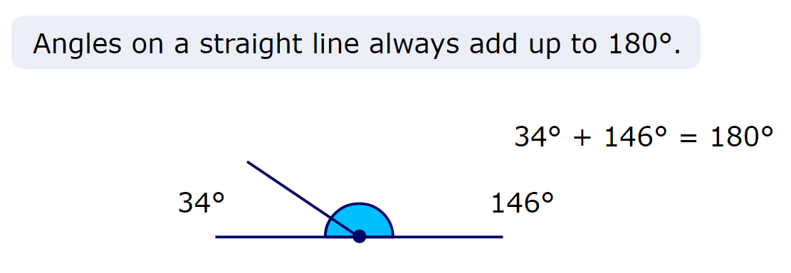

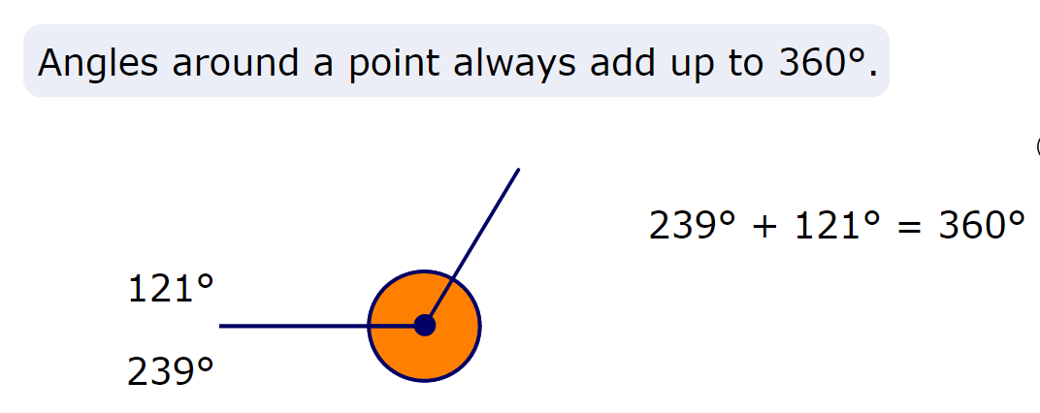
239⁰

