How to make a naught and crosses game

You will need:
Piece of card
Ruler
Pencil
10 bottle lids (preferably the same size and colour)
Black and White paint (or two other colours or felt tip pens)

Step 1 – Measuring and marking out
Place your ruler at the edge of the card. The measurements on a ruler do not start straight away. Have a look at this picture for where the measurements start.
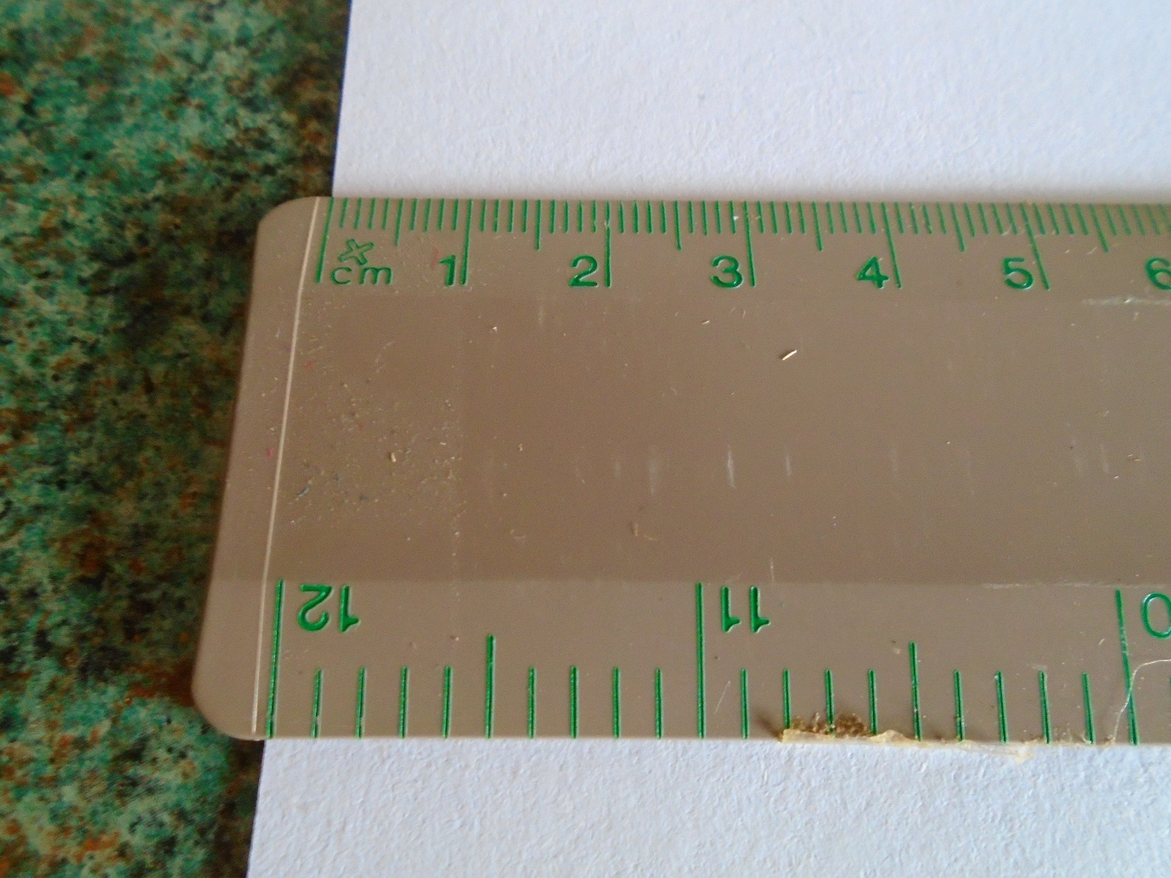

Measure across and place a mark on where it says 15cm
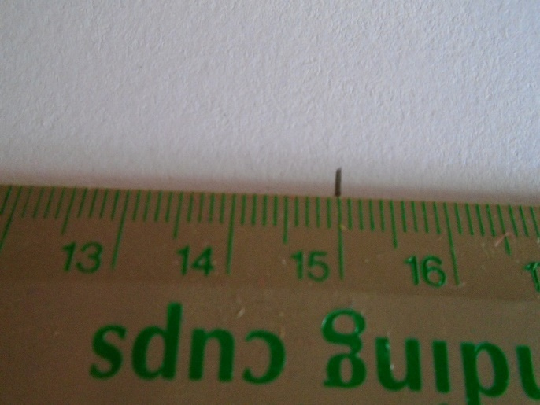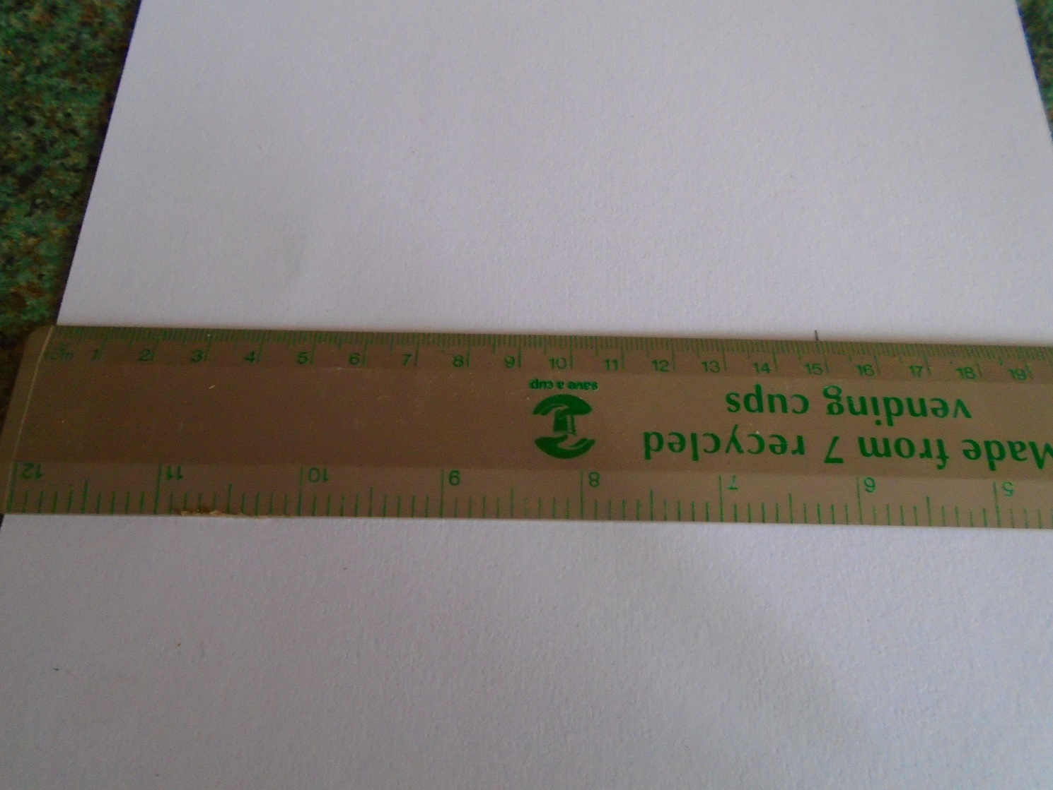

Now do the same and draw another line further down the card.

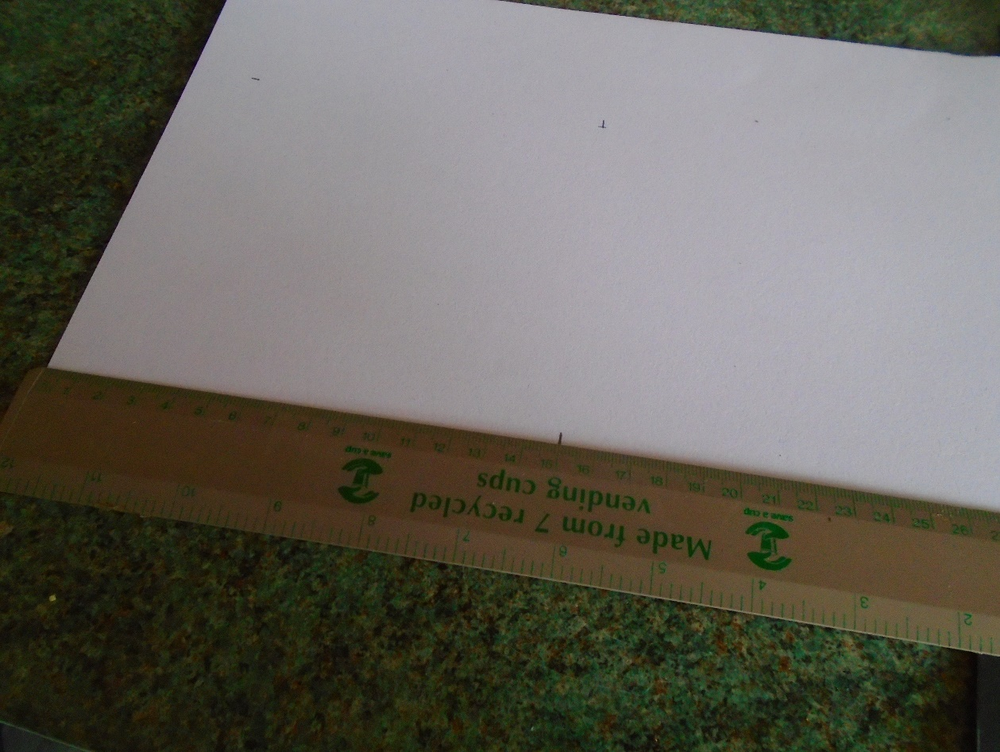
Now turn your ruler around and draw a line to join these two marks
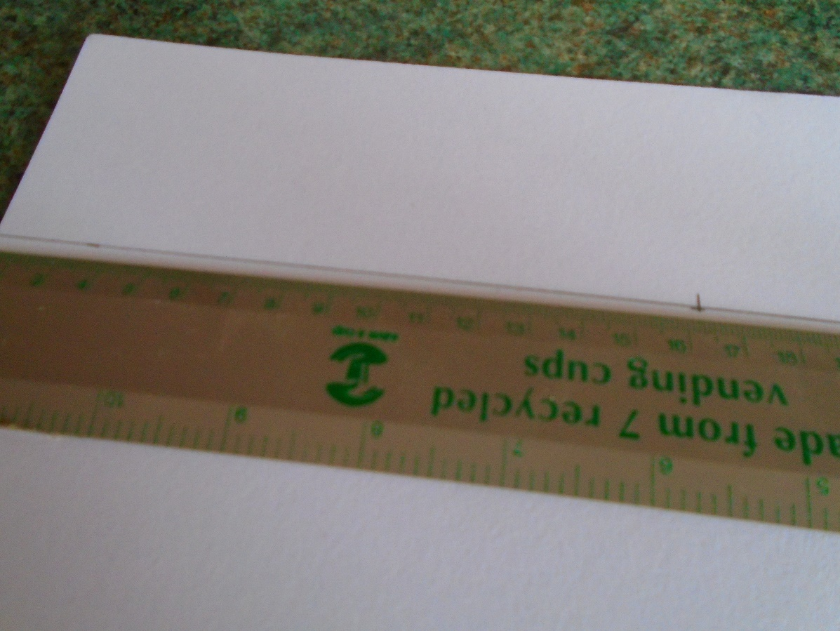
Now measure across the opposite way and do the same thing again so that you have a square that measures 15cm x 15cm
Step 2 – Cut out your 15cm x 15cm piece of card
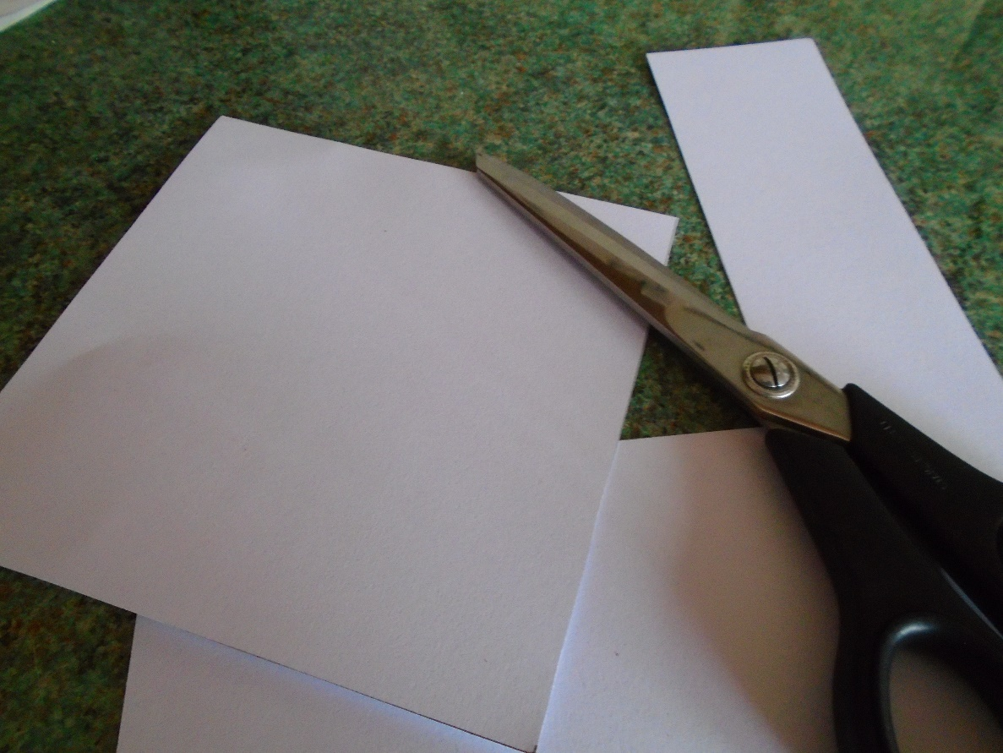
Step 3 – Paint
Paint your piece of card black and put this to one side to dry.
Only use a thin layer of paint otherwise it will take a long time to dry. You could use a hair dryer to dry it quicker.
You could also use felt tip pens
Or if you have a piece of black card you will not need to paint it.
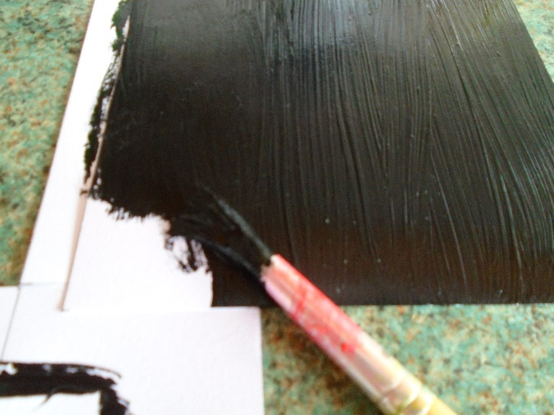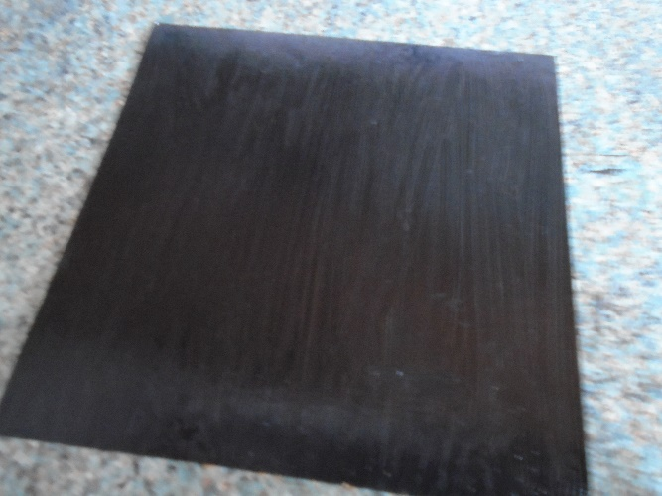

Step 4 – Bottle lids
Divide up your bottle lids into 5 and 5
Paint an X on 5 of them. (Use a thin brush to do this)
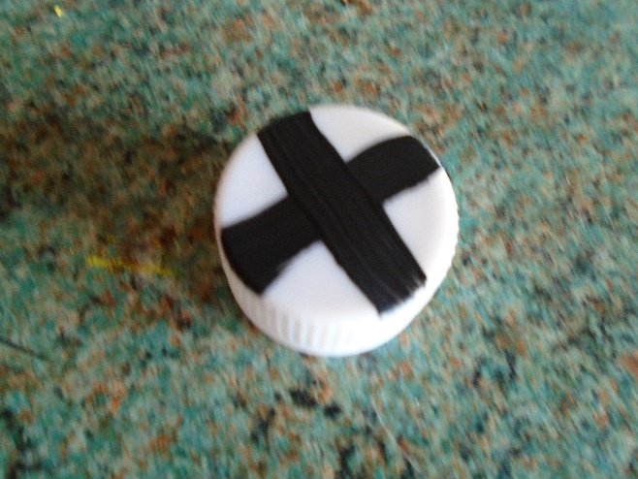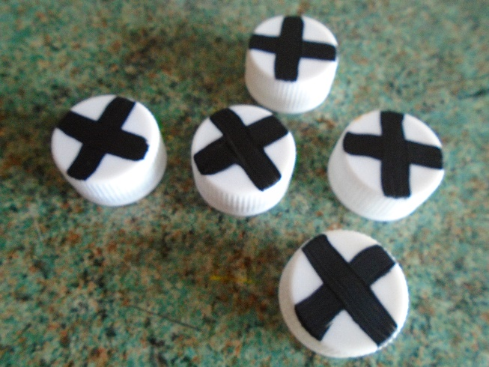

Now paint the other 5 white (If there is no writing on the top you don’t need to paint them)

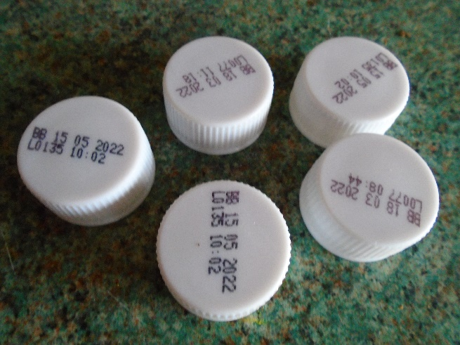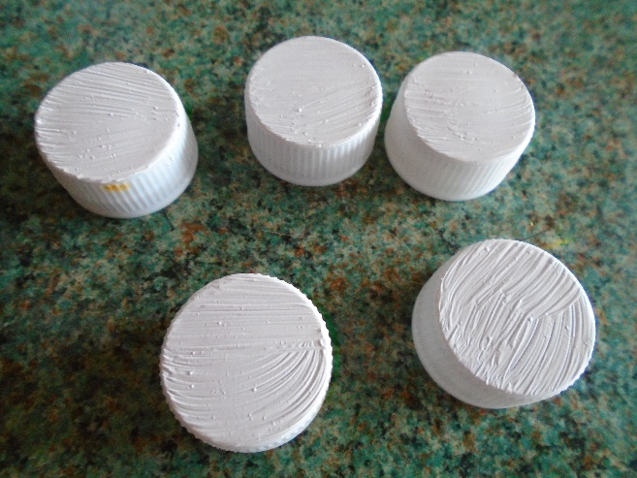

You should now have 5 white lids and 5 with crosses on like this
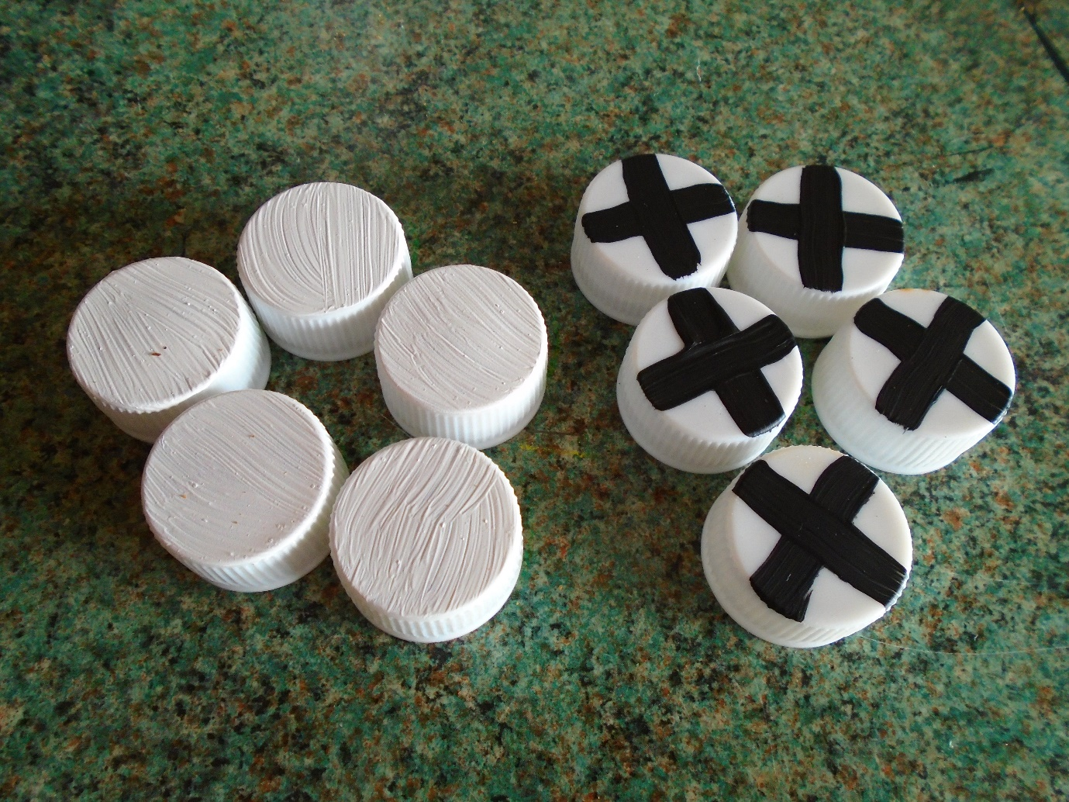

Step 5 – Continue marking out the card
Divide up your card into squares
With your ruler, measure and mark out 5cm and 10cm – place a mark at each point

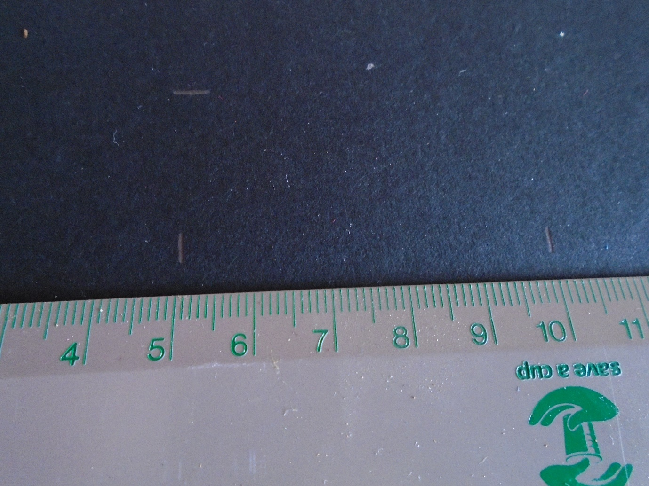
Now mark two more lines further down the page
Then draw a line to join them up.
Turn your piece of card around and draw two more lines across the piece of card.

It should now look like this
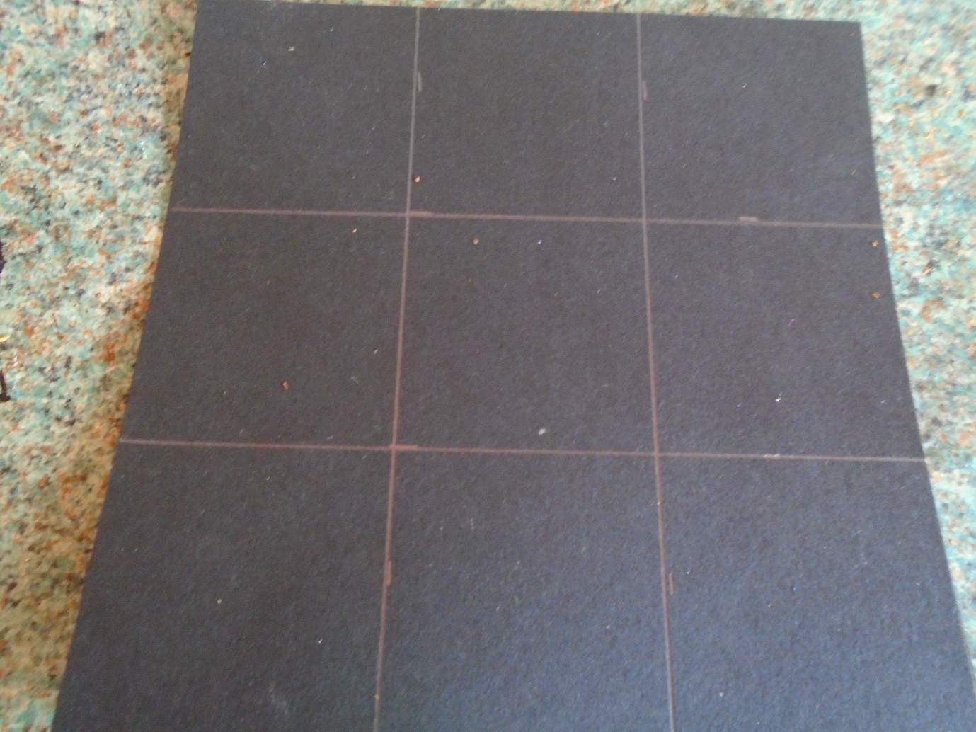
Use a felt pen to make these lines thicker and to stand out better

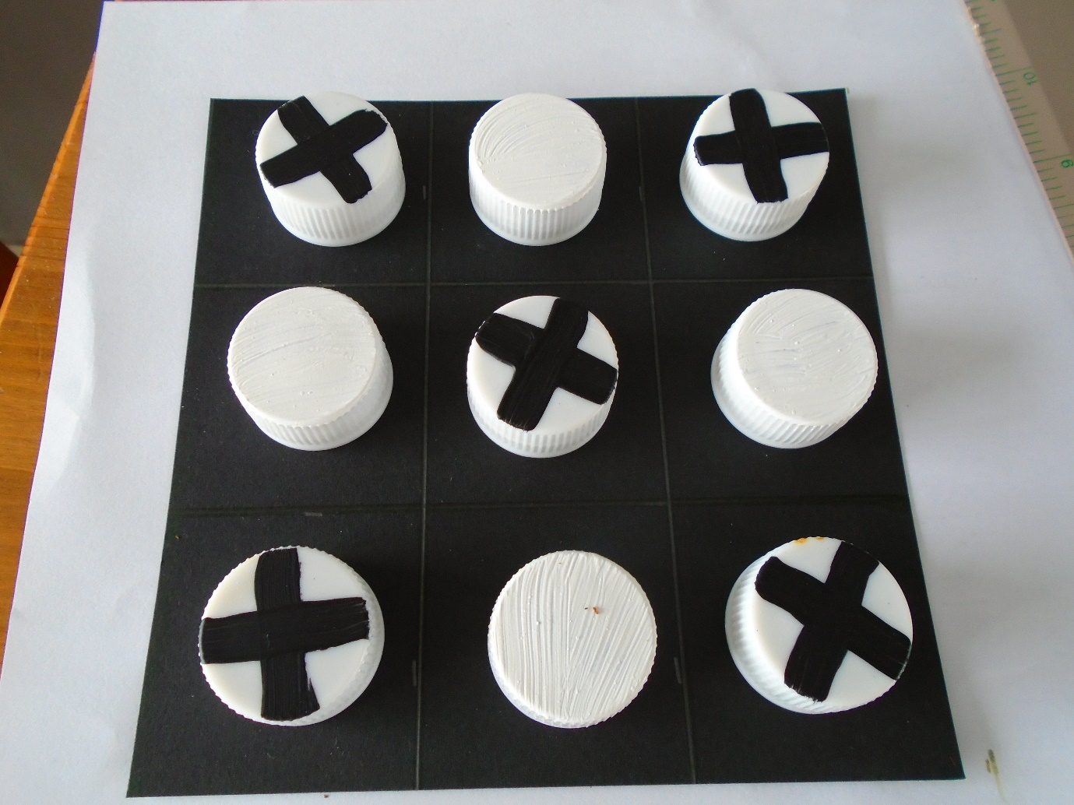

Naughts and Crosses

If you haven’t played it before;
you need 2 players.
One person has the x’s and the other has the Os
In turn you need to place one of your pieces onto the board
You need to try to get 3 in a row
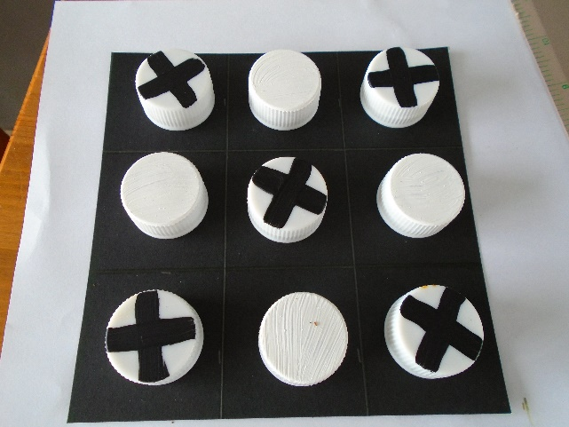 X player wins
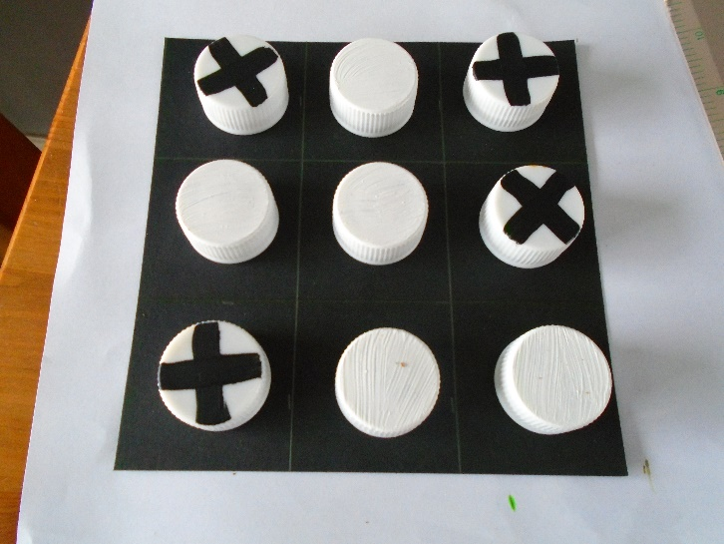 O Player wins
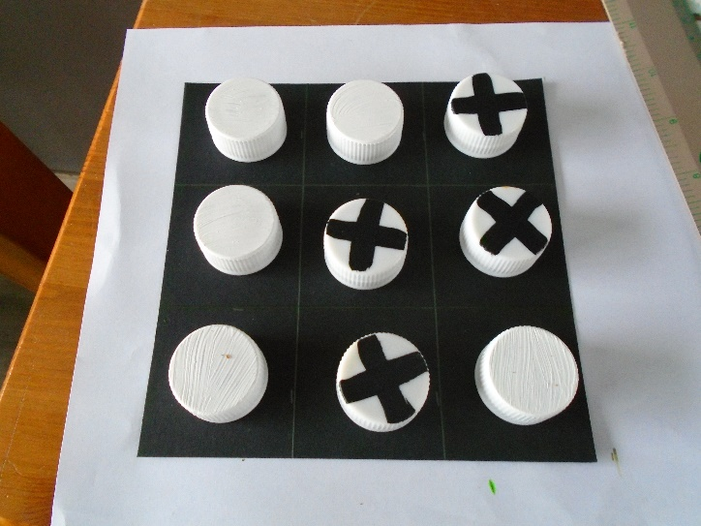 O player wins

