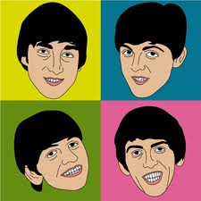
The Beatles
Name Form

The Beatles were perhaps the most influential group of the 1960’s. They formed in Liverpool in the late 1950’s playing in the Cavern Club in Liverpool and became famous in the early 1960’s with records such as She Loves You. There were four of them – John Lennon, Paul McCartney, George Harrison and Ringo Starr. Their style developed constantly over the next few years, the Sergeant Pepper’s Lonely Hearts Club Band album of 1967 being a landmark in the history of rock music. In this album, The Beatles insisted that everything had to be different, therefore pushing music technology into new areas. The Beatles split up in 1970, developing their careers separately. John Lennon was killed in 1980 and George Harrison died on 30th November 2001. Paul McCartney was knighted in 1997 making him Sir Paul McCartney for his outstanding contribution to the music industry over the years.
1. How many Beatles were there?
2. Write their names in alphabetical order
3. Where did The Beatles come from?
4. Which years were The Beatles famous as a group in?
5. Who was knighted in 1997 and why?
6. Do you know any Beatles songs? If so, what are they? Do you have a favourite?

