Learn About Spreadsheets
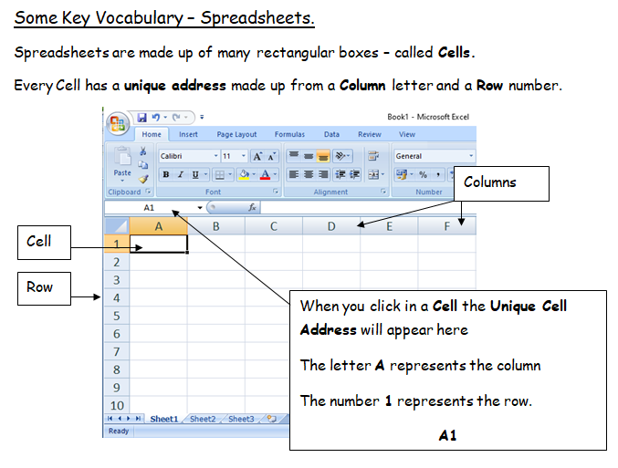

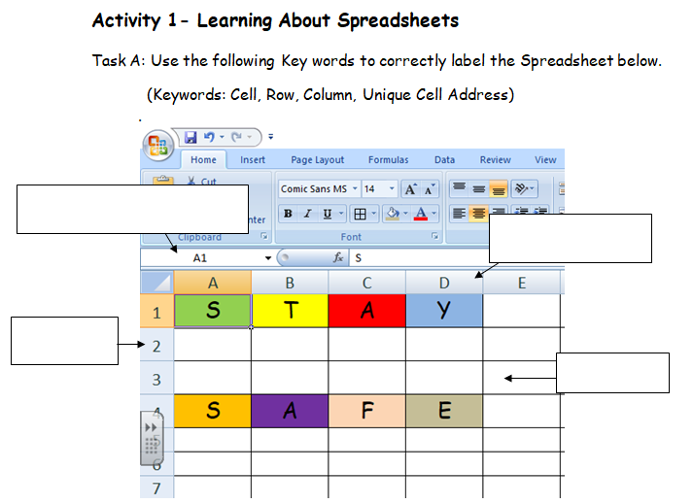
Task B: Cell Referencing
Work out the Unique Cell address for each letter in the worksheet above. (The first one has been completed for you – Good luck!)
- Green S = A1
- Yellow T =
- Red A =
- Blue Y =
- Gold S =
- Purple A =
- Pink F =
- Grey E =

Activity 2: Practice Cell References
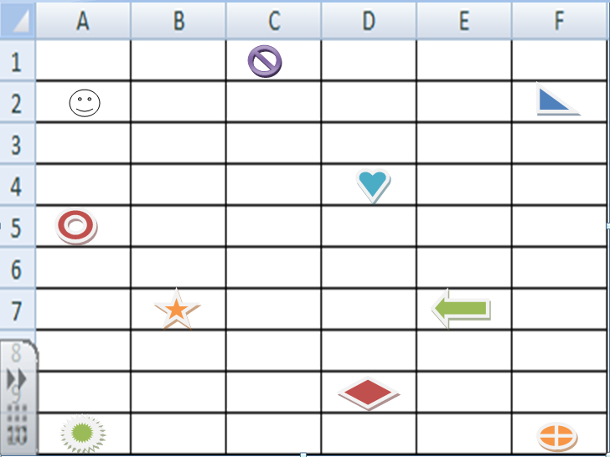
Activity 2: Using the spreadsheet above work out the cell reference of each shape and write it in the table below.

