Angles in Polygons Challenge
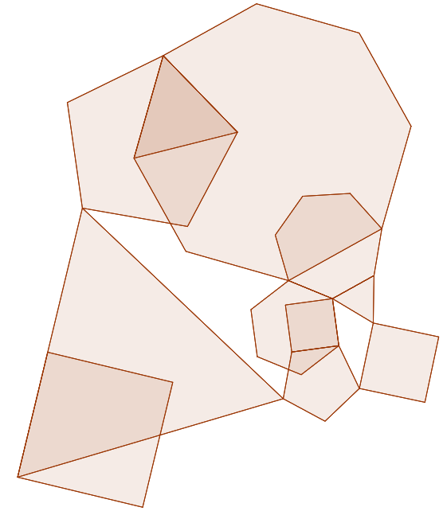
This image has been create by layering lots of regular polygons on top of each other. Find ALL the angles contained within the diagram (be careful, some lines look straight where one polygon ends and another begins). There are some irregular polygons created by the layering so you may need to look out for these.
If you manage all the angles within the polygons, what about those that are in the white polygons?

