Limestone Quarry Public Enquiry
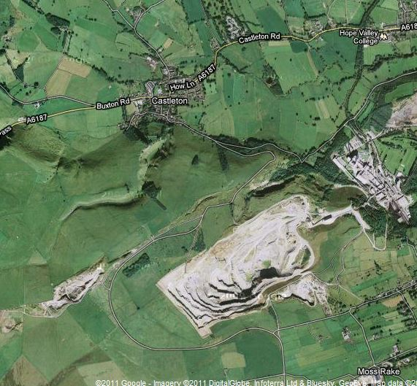
4 Hills Quarry, near Castleton in Derbyshire, wishes to extend. Currently it produces 1.5 million tonnes of limestone for cement making per year, but now wishes to expand into limestone blocks for building.
They intend to extend out in a south-westerly direction, doubling the size of the quarry.

Castleton is a small village of about 700 inhabitants. It is a very important tourist centre, but since the mining industry collapsed there has been a shortage of jobs .

You are members of the jury at a public enquiry, debating whether to let the extension go ahead. Your job is to study the evidence given and make a decision, also saying why you made that decision.
The limestone is partly processed on site, but is taken away to a cement factory in Warwickshire by truck. If the extension goes ahead, the access road to the site will need to be improved to cope with the extra traffic.
Castleton has one main road running through it, which is a single carriageway A- Road going straight through the village centre. All other roads in the area are single track country lanes.
The quarry is situated in the peak district national park, an area of outstanding natural beauty. The limestone rocks locally are an internationally important habitat for rare plants, and attract thousands of tourists every year.

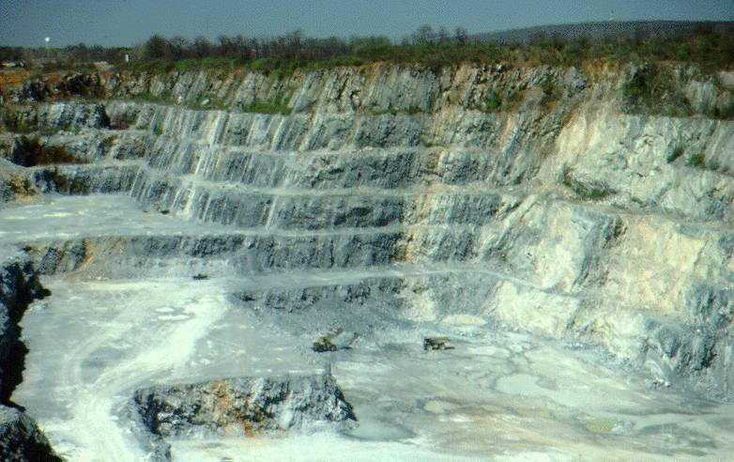
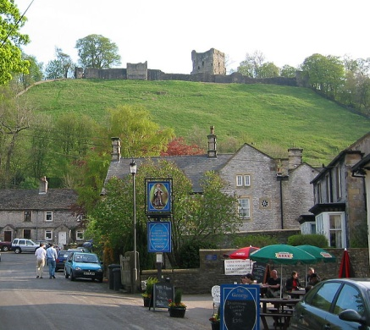

After reading the briefing sheet, what is your first decision?

Why has your group decided this?

Now you will be given the first and second pieces of evidence, read them carefully

Have you changed your mind? YES / NO

Give your reasons

Now read the third and fourth pieces of evidence.

Have you changed your mind? YES / NO

Give your reasons

What is your group’s final decision on the extension to the quarry?

Which piece of evidence was most important for your decision and why.

rou
Evidence 4: Areesha Khan, 16, Castleton Resident

I am really keen for the development to go ahead. I left school last year and have been unable to get a job. I have loads of qualifications but there is just nothing round here. If the quarry expanded there would be jobs for digger drivers, office workers, scientists. It would be a fantastic opportunity for me and loads of people like me.
Evidence 3: Anthony Diasu, Derbyshire Wildlife Trust

This development must not be allowed to go ahead! There are several rare species of plants in the area that will be dug up, as well as one species of insect that is only found in this region. This is an internationally important site from a wildlife point of view, and extending the quarry could cause at least one species to become extinct.

Evidence 2: Lucy Archer, 4 Hills Quarry Chief Executive

We Believe that the expansion of the quarry is essential for the local area, because the quarry employs 30 local people. In an area with high unemployment, the extra 20 jobs the expansion will bring will really help people in Castleton.
Evidence 1: Bill Wareham, local council

We are against the extension to the quarry for two reasons. Firstly, the extra traffic through the village will cause extra noise, congestion and the risk of accidents will increase. We will have to spend millions of pounds upgrading and repairing local roads

Secondly, we are concerned that the damage done to the local area will have a massive impact on the tourist industry. Hundreds of local jobs depend on tourists in shops, cafes and bed and breakfasts, all of which will be adversely effected.

