LO – To be able to identify and record the range of possible outcomes of combined events.

Complete the Listing Outcomes task on mymaths.
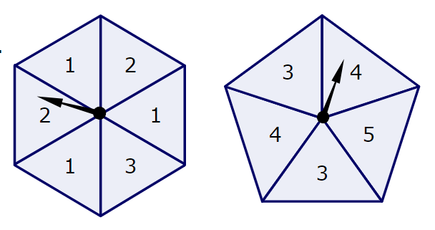
Answer the following questions.
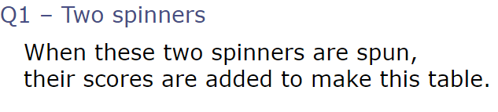

 | 1 | 2 | 1 | 3 | 1 | 2
3
4
5
3
4

6

Greater than 5

s | f | l
s | f | b
