English Tasks Week 7

1. Create a conversation between you and the old man
Use your best questions from last week to help create dialogue (speech) between the characters. You may add/colour the other character if you wish

2. Write your speech up into sentences
Remember you will need to be using speech marks and different words for said as below. There is guidance to help you.

3. Think about an adventure you and the old man could go on together.
Create a short comic strip with pictures and sentences.
- Where will you go?
- What will you do?
- What problem could you face?
- How could it be resolved?

Hello stranger, what are you doing in my mystical, secret shed?
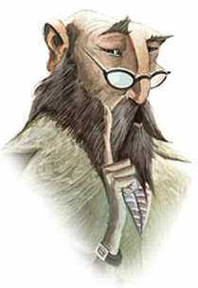

Imagine how he will answer
Ask your first question

Ask your next question

Imagine how he will answer

Speech punctuation
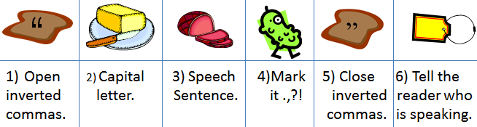

Alternative words for said
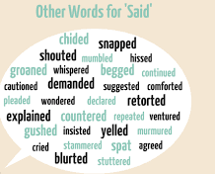

Comic Strip
Where will you go? | What will you do?
What problem could you face? | How could it be resolved?

