LO – To be able to describe probability as a numerical measure.

Complete the Simple Probability task on Mymaths.
Answer the following questions.

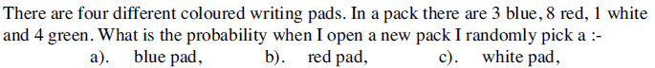
1)

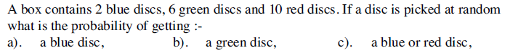
2)

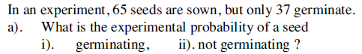
3)

4)

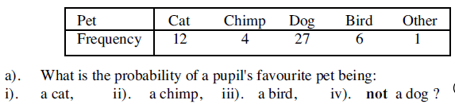
5)

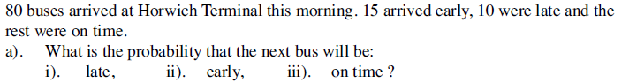
6)

