Science Year 7 Notes 10/06/2020
LO: To Know What the Bones Are Made of.
Bones are hard on the outside and spongy on the inside
The spongy part is called Bone Marrow and this is where cells are made.
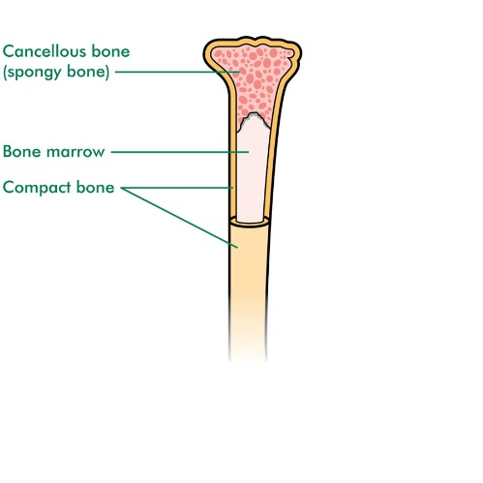
Facts about bones:
There are 3 parts that make up a bone;
- Hard outside
- Spongy inside
- Bone marrow where the cells are made
- The mineral that we need to make strong, healthy bones is called Calcium
- Bones have to be able to flex a little bit or they will break when put under stress.
- Not all bones are the same because they have different purposes.
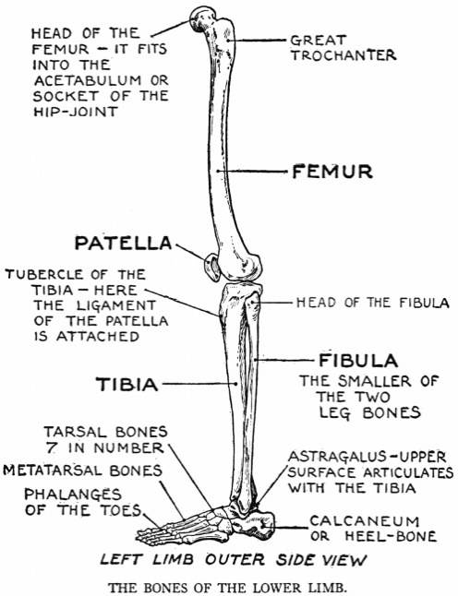
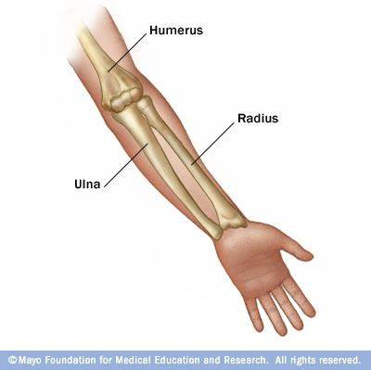
Homework: for 17/06/2020
Write a sentence about the meaning of the following;
- Bone
- Calcium
- Marrow
- Vertebrae
Email to
Binda.taylor@grangepark.kent.sch.uk

Leg bones need to be big and strong so we can walk and hold our weight.
The fingers have the largest amount of bones but are small because the make very small movements.

